The objective of this study is to use leading economic measures to forecast the volume of interest bearing deposits can be expected by four quarters of the next four years.

In order to predict the

amount of deposits can be expected. Based on the actual CD data provided (1984-2016),

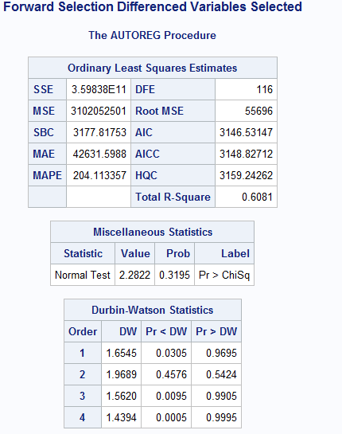

<https://www.statisticssolutions.com/autocorrelation/>

<https://www.statisticssolutions.com/missing-values-in-data/> info on missing reasoning for eliminating the missing vix info.

Reduction in sample size as explained by ch.11 of textbook. Sample size in time series is the amount of time periods. Sacrificed

Durbin after No VIx

